

**ENGINEERS & CONTRACTORS**

***Ref. No. Date: <To>***

**TO WHOM IT MAY CONCERN**

It is certified that Mr. <Name> S/o <fname> worked in this organization w.e.f. <From> to <To> in the capacity of <Designation> at different projects.

His performance has been exemplary and to the entire satisfaction of his superiors. He is professionally sound and his approach to his work indicates zeal and enthusiastic to learn. He is an honest, punctual and devoted person. He bears a good moral character.

He is still working in our organization and we wish success in

his future.

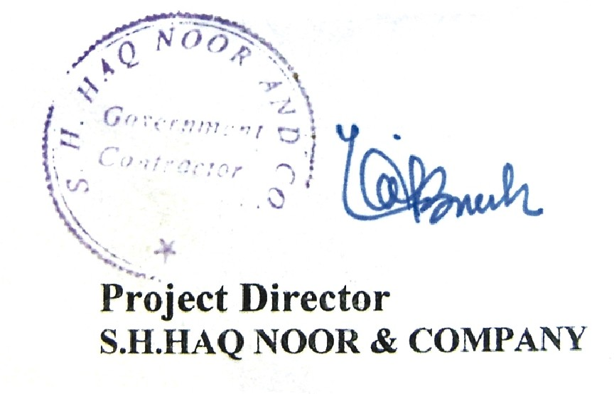

**Head Office:** Syed Manzil Prince Road, Quetta. Ph: 081-836249 Fax: 824742 Mob: 0300-3060266

**Branch Office:** 5-Chandni Chowk, Main University Road, Karachi. 021-4942413 4944152 Fax: 4939089